**Middle College at APSU- Dual Enrollment Grant Application Instructions**

1. Go to <https://www.collegefortn.org/tennessee-financial-aid/>
2. Click on **Visit the TSAC Student Portal**.

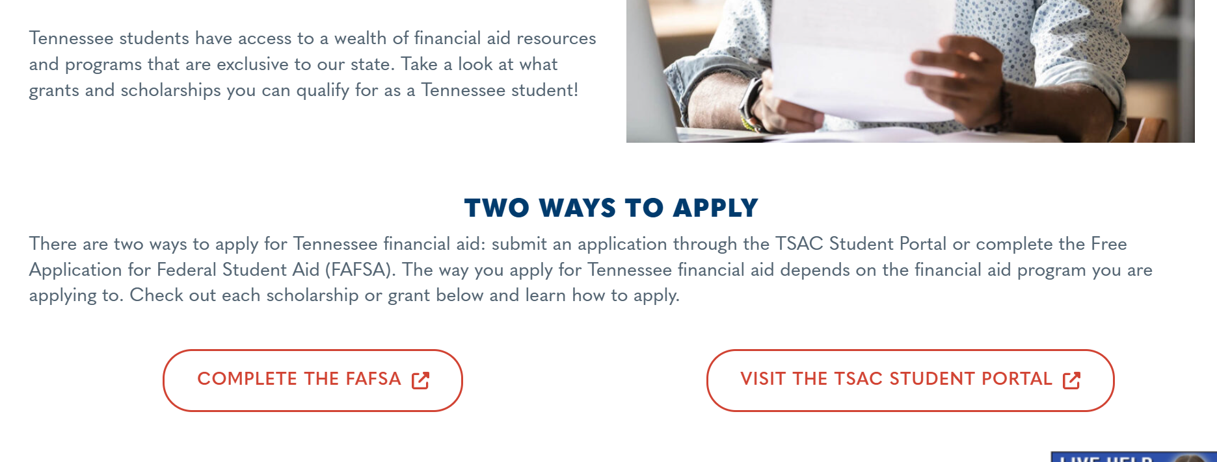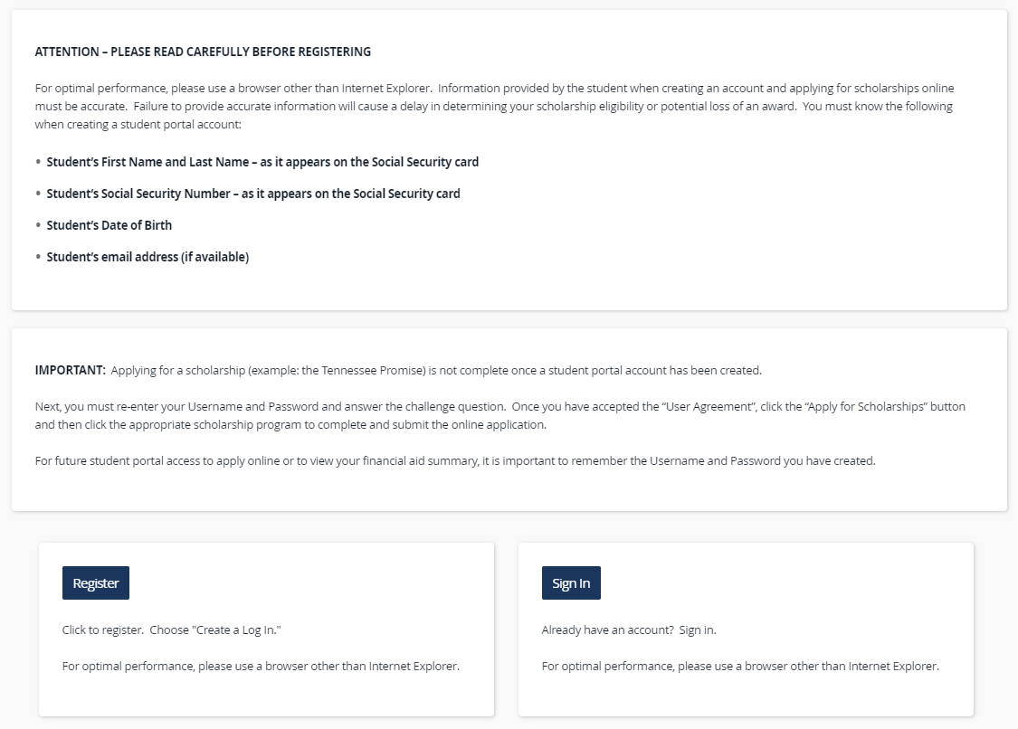

3. **Click to Register**, or **Sign In** if you already have an account.

(Returning seniors and associate juniors already have an account. Skip to step 6.)

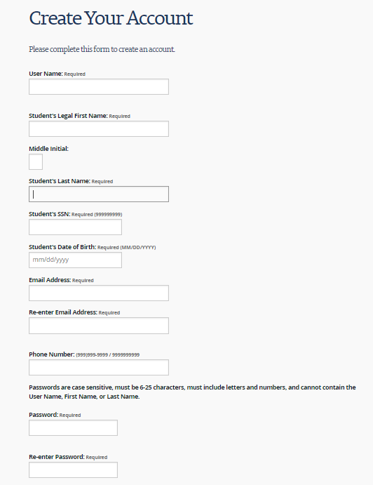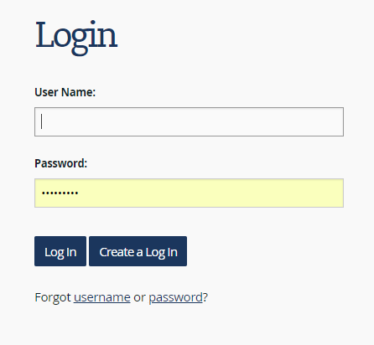

NOTE: The user name must be a combination of letters **and** numbers— no special characters.

4. *If you have completed a TN Promise application before, you already have an account. Use your account credentials to log in now.*

If you are new and registering, click **Create a Log In**. You will be taken to the form below. Complete the form to create an account.

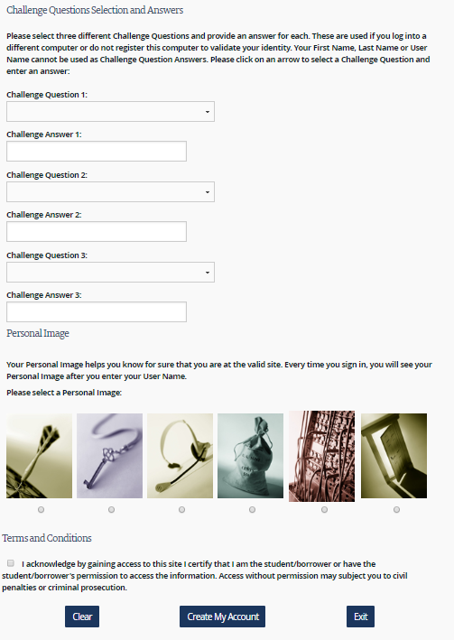

5. Once you’ve successfully created an account, you will see this message:

**Click here to log in to your account and apply online.**

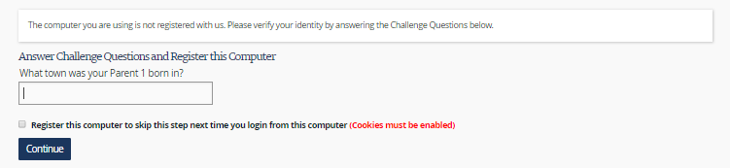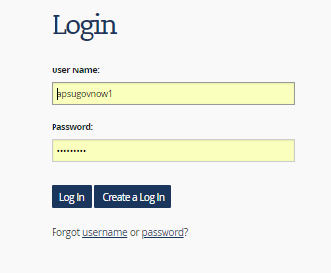

8. Confirm the personal image matches the one you selected when creating your account by clicking **Continue.**

6. Enter the log in credentials you created for your account. Click **Log In**.

7. Answer your challenge question, if required and click **Continue**.

9. Acknowledge the User Agreement by clicking **Accept**:

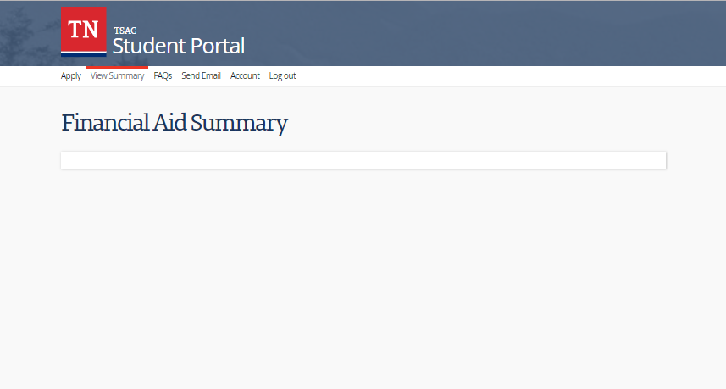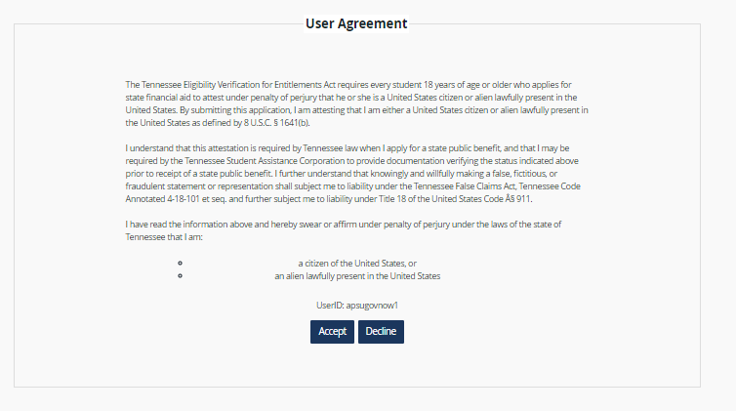

10. When you see the Financial Aid Summary screen, click **Apply** to navigate to the dual enrollment grant application.

11. You will see a list of scholarships. Select the **Dual Enrollment Grant for Fall 2023, Spring 2024, Summer 2024**.

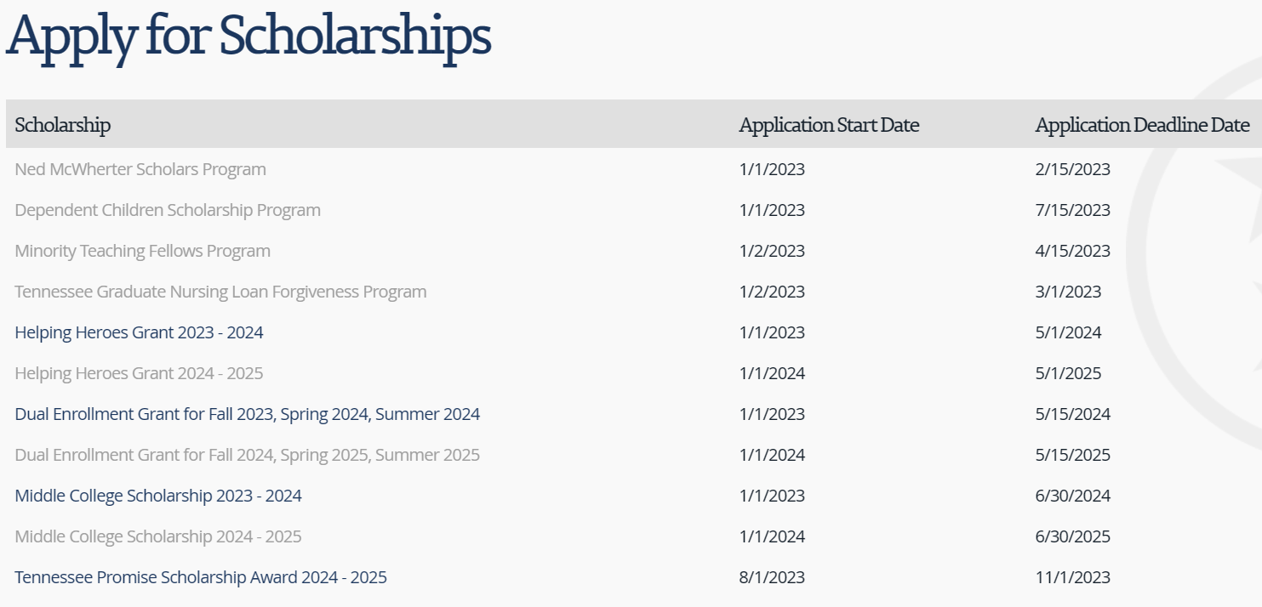

12. Acknowledge the General Requirements and Instructions by clicking **I Understand**. Then select the **Dual Enrollment Grant**. Do not select Middle College!

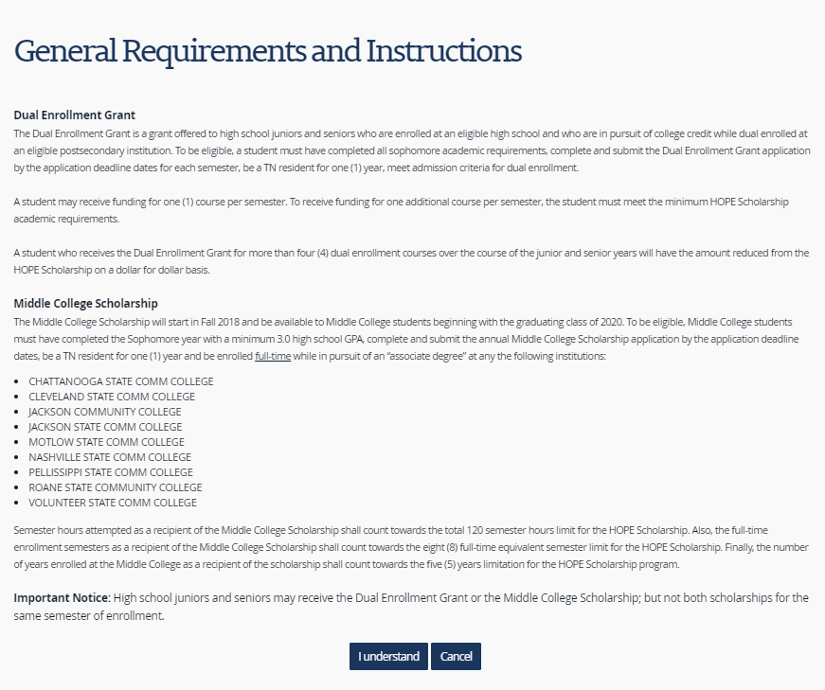



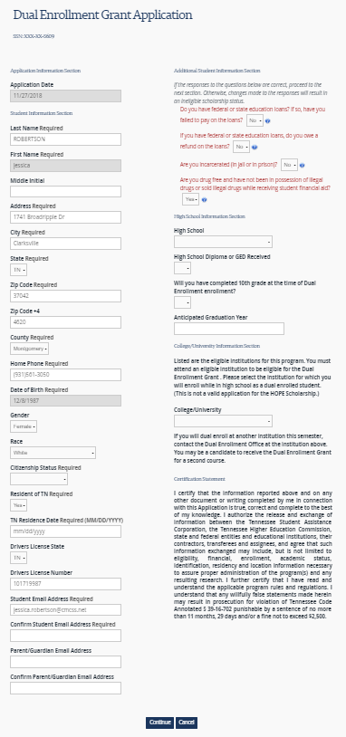13. Complete the application and click **Continue**.

NOTE: Your residency date is the day you began living in Tennessee. If you were born here and have never lived in another state, you will put your birthday.

NOTE: Under the “College/University Information Section”, choose Austin Peay State University.

For high school, select “**Middle College at Austin Peay**”. Do not select the high school you attended last year!

14. 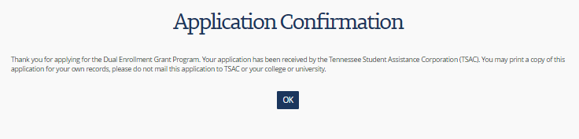CONGRATS! You have completed your Dual Enrollment Grant application. Click **OK**. You can print or screenshot the confirmation page for your records. You do not need to send the confirmation page to Ms. Mendoza.

