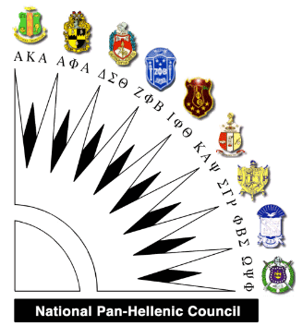 | To: College-Bound High School Seniors  From: National Pan-Hellenic Council,  Clarksville Chapter  Re: Scholarship Opportunity
The Greater Clarksville National Pan-Hellenic Council (NPHC) is now accepting applications for our 2019-2020 NPHC Scholarships. Our scholarships are available to qualifying high school seniors enrolled in the Clarksville-Montgomery County School System who plan to continue their education after graduation.
The 2019-2020 NPHC scholarships will be awarded to first-place ($600.00) and second-place ($400.00) winners. The scholarship committee will thoroughly review each application packet received to determine the first and second-place winners. Notification will be sent to the winners via mail no later than April 15, 2019.The scholarships will be made payable to the respective university or college in the recipient's name upon receipt of enrollment verification.
The following items are required by Monday, April 1, 2019 in order to be considered for our 2019-2020 NPHC Scholarships:
- Completed Scholarship Application
- 1-2 Page Essay (Topic: “Why I Should Be Awarded a 2019-2020 NPHC Scholarship”)
- Letter of Recommendation (from applicant’s school administrators, faculty or guidance counselor)
- Official Transcripts (student MUST have an overall 3.0 GPA or higher)
Any questions should be directed to the National Pan-Hellenic Council Scholarship Chairperson, Margaret Thompson, at GreaterClarksvilleNPHCScholar@gmail.com.
Please send the completed application to the address below by April 1, 2019:
National Pan-Hellenic Council
Attn: Scholarship Committee
P. O. Box 466
Clarksville, TN 37041-0466
NATIONAL PAN-HELLENIC COUNCIL- CLARKSVILLE CHAPTER
SCHOLARSHIP APPLICATION
Return by 04/1/2019 Application Date _________ HS Graduation Date ________
Name_________________________________________________________________
Last First Middle
Date of Birth Ethnicity
Street Address __________________________________ Phone
City, State ____________________________________ Zip
E-mail Address: ______________________________________________
Desired College Major Minor
Total HS credit hours completed as of December 2018________ GPA
PLEASE ENCLOSE ONE COPY OF YOUR OFFICIAL TRANSCRIPT WITH THIS APPLICATION.
Discipline infractions this academic year (circle one) YES NO
If YES, please explain: ______________________________________

___________________________________________________

___________________________________________________
List awards and honors you have received: ____________________________________________________________________________________________________________

___________________________________________________

____________________________________________________
List organizations to which you belong and offices you held:
____________________________________________________

____________________________________________________

In this space describe your career plans:
_________________________________________________________

_________________________________________________________

_________________________________________________________

Describe briefly any community service performed:
_________________________________________________________

_________________________________________________________

Aside from a college degree, what do you hope to gain from your college experience?
_________________________________________________________

_________________________________________________________

_________________________________________________________

_________________________________________________________

_________________________________________________________

_________________________________________________________

_________________________________________________________

_________________________________________________________

________________________________________________________

_________________________________________________________

_________________________________________________________

