To: Female College-Bound High School Seniors

From: Zeta Phi Beta Sorority, Inc -Rho Mu Zeta Chapter

Re: Scholarship Opportunity
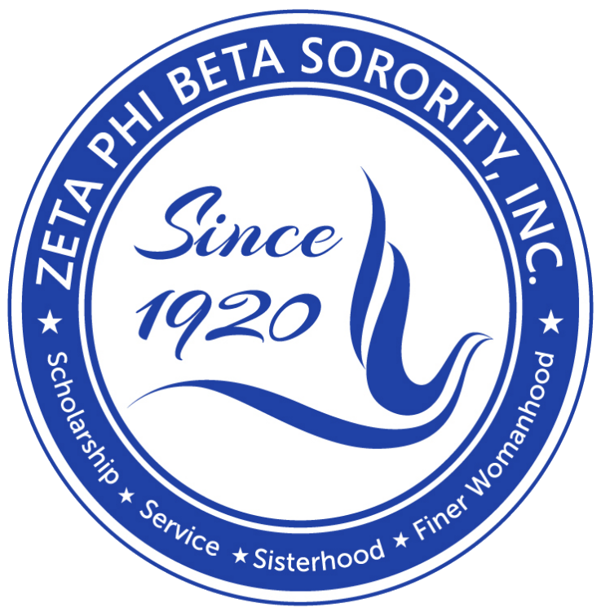

The Scholarship Committee of Rho Mu Zeta is accepting applications for the Annual Michelle Merritt Scholarship Program for school year 2019-20. It is available to qualifying high school female seniors enrolled in a Clarksville-Montgomery County school.

This scholarship is for $500 and is payable to the university or college in the student's name upon verification of enrollment.

The following documents are needed to submit an application to Rho Mu Zeta by
Feburary 1, 2020:
- Completed Michelle Merritt Scholarship Application Form
- An Official Transcript of courses and grades (student MUST have a 3.0 GPA or higher)

Members of Rho Mu Zeta will review application packets to select the scholarship recipient. Notification of scholarship award will be received by mail no later than March 1. Selected recipients will be invited to the annual Scholarship Tea for public recognition. Recipients will receive two complimentary tickets- others can be purchased through the chapter website: http://www.clarksvillezetas.org/

Any questions should be directed to the Rho Mu Zeta Scholarship Chairperson, Dr. Eva Gibson at ZPBscholar@gmail.com.

Additional scholarship opportunities can be found at the national website: http://www.zpbnef1975.org

Send completed application by Feb. 1, 2020 to:
Zeta Phi Beta Sorority, Inc
Rho Mu Zeta Chapter Attn: Scholarship Committee
P. O. Box 30013
Clarksville, TN 37040

Michelle Merritt Scholarship Application
Presented by RHO MU ZETA

Return by Feb. 1

Name
Last First Middle

Date of Birth Ethnicity

Street Address Phone

City, State Zip

E-mail Address: ______________________________________________ Expected HS Graduation Date

Desired College Major Minor

Total HS credit hours completed as of December 2019 GPA Total absences

PLEASE ENCLOSE ONE COPY OF YOUR OFFICIAL TRANSCRIPT WITH THIS APPLICATION.

Discipline infractions this academic year (circle one) YES NO

If YES, please explain:

List awards and honors you have received:

List organizations to which you belong and offices you held:

In this space describe your career plans:

Describe any community service performed:

Have you participated in a Greek Letter Youth Group: If yes, what organization?

Describe your participation:
Is anyone in your family a member of a Greek Organization? If yes, who?

Which organization?

Attach an essay addressing the following prompt:
Michelle D. Young-Merritt was a Zeta woman who gave back to her community through her service and leadership. She worked with needy children and families and contributed many volunteer hours to local organizations. Michelle believed in helping other people excel. How will this scholarship assist you personally? How will you help other people excel?

*It is suggested that you type your essay according to the following guidelines: 1 page, double spaced, 12 size, times new roman font.

STATEMENT OF AGREEMENT
I agree to allow Rho Mu Zeta Chapter to use written statements, photographs, or other media of my likeness online and in print publications, communications or other forms of media.

Signature Date

Additional scholarship opportunities can be found at the national website: http://www.zpbnef1975.org

